MAURITIUS ATHLETICS ASSOCIATION
ROAD RACE

Sunday 11 June 2023

Ebène Cyber City

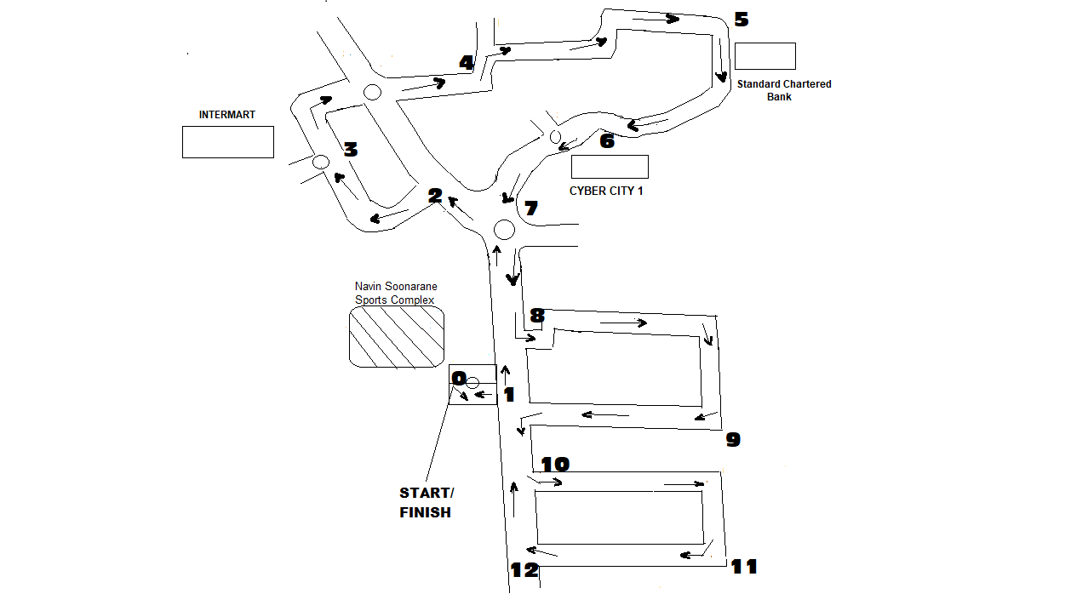
COURSE PLAN

CIRCUIT: 1 – 2 – 3 – 4 – 5 – 6 – 7 – 8 – 9 – 10 – 11 – 12 = 5 KM

TIME | EVENTS | CIRCUIT | DISTANCE
07.00 H | ROAD RACE | Departure O + 3 Circuits – Arrival O | 15 KM
07.30 H | ROAD RACE | Departure O – 1 Circuit – Arrival O | 5 KM
08.00 H | FUN RUN | Departure O – 1 – 8 – 9 – 10 – 11 – 12 – 10 – 1 – Arrival O | 3 KM

