MAURITIUS ATHLETICS ASSOCIATION
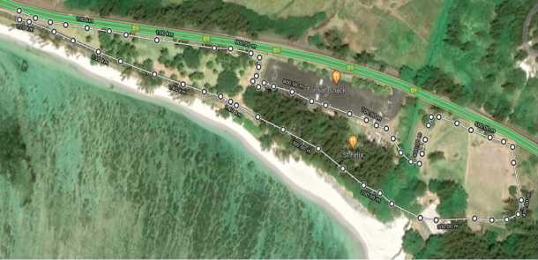

VITAL CROSS COUNTRY LEAGUE 2023
Leg 2 – Public Beach, St FELIX on Saturday 04.03.2023

F
E

H

X
A
C

B
G
X1
Parking
D
St FELIX Public Road

CIRCUIT (1) A + B + C +D + E + F + G +H + A 1.5 Kms
CIRCUIT (2) A + X1 + C + D + E + F + G + H + A 1 Km

1 | 09:15 hrs. | U10 (B)- (G) | Dep - E - F - G - H - A - X | 0.6 Km
2 | 09:30 hrs. | U12 (B) - (G) | Dep A + 1 * CIRCUIT 2 - X | 1 Km
3 | 09.45 hrs. | U14 (G) | Dep A + 1 * CIRCUIT 1 - X | 1.5 Kms
4 | 10.10 hrs. | U14 (B) / U16 (G) | Dep F + 2 * CIRCUIT 2 - X | 2.5 Kms
5 | 10:15 hrs. | SEN (M) | Dep F + 4 *CIRCUIT 1 - X | 6.5 Kms
6 | 10:40 hrs. | U16 (B) /U18 (W) & MASTERS(W) | Dep F + 2 *CIRCUIT 1 - X | 3.5 Kms
7 | 11:00 hrs. | U18 (M) | Dep F +3* CIRCUIT 1 - X | 5 Kms
8 | 11.20 hrs. | U20 (W) / SEN (W) | Dep A + 3 * CIRCUIT 1 - X | 4.5 Kms
9 | 11.40 hrs. | MIXED RELAY: U14 | 2Girls + 2 Boys | 4 X 400 M
10 | 11:45 hrs. | MIXED RELAY: U18 | 2Girls + 2 Boys | 4 X 500 M
11 | 11:50 hrs. | U20 (M)  MAS (M) | Dep A +5* CIRCUIT 2 - X | 5.5 Kms
12 | 11:55 hrs. | Fun Race | Dep A +2* CIRCUIT 2 - X | 2 Kms

