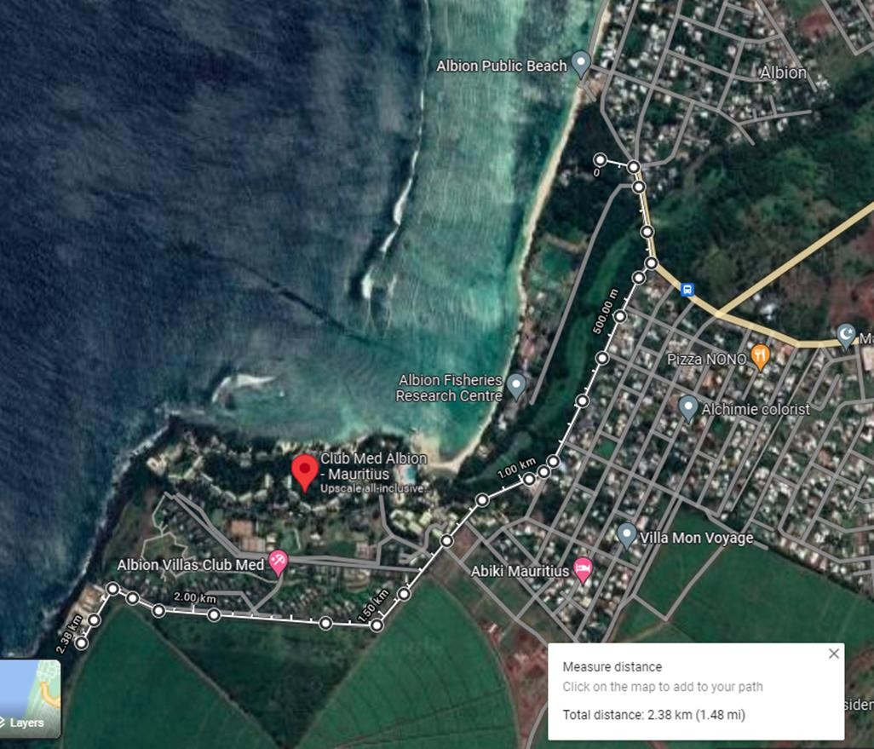
MIXED ROAD RELAY 15 KM CIRCUIT & FUN RUN
Course Plan
A
B
C
D
Mauritius Oceanography Institute
CLUB MED MAURITIUS
Albion beach car park

Turning Point 5

Turning Point 4

Turning Point 3
Turning Point 2

START, CHANGE OVER AND FINISH at Albion Beach Car Park

CIRCUIT: A + B + C + D = 2.5 KM

08.00 hrs

NO | CAT | GENDER | CIRCUITS | DISTANCE
1st Leg | SENIORS/MASTERS | MEN | START A – B – C – D – C – B - A | 5 KM
2nd Leg | U20 | MEN | START A – B – C – T/POINT 2 – C – B -A | 4 KM
3rd Leg | U18 | BOYS | START A – B – C – T/POINT 3 – C -B - A | 3 KM
4th Leg | U16 | GIRLS | START A – B – T/POINT 4 – B - A | 2 KM
5th Leg | U14 | GIRLS | START A – B – T/POINT 5 – B - A | 1 KM

09.00 hrs :FUN RUN – CIRCUIT: A + B + C + D = 2.5 KM

