TRAIL
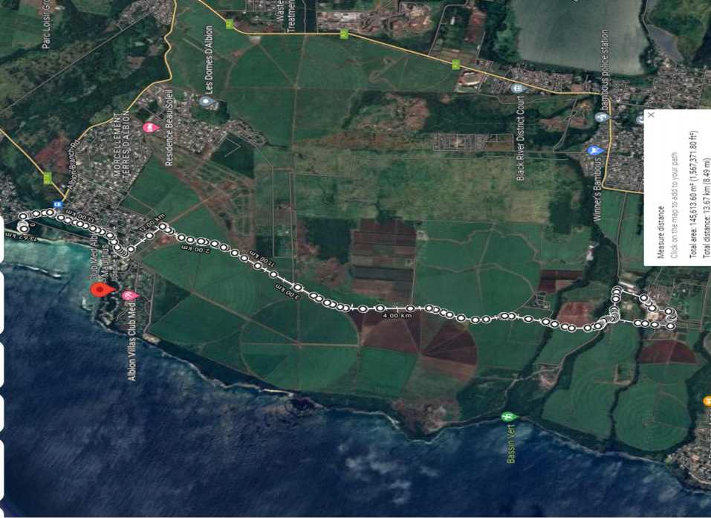
Course Plan
B
C
A
F
D
E
MEDINE SUGAR ESTATE
Albion beach car park
DEPART – A- B – C – D – E – F – D – C – B – A = 15 KM – 07.00 HRS

