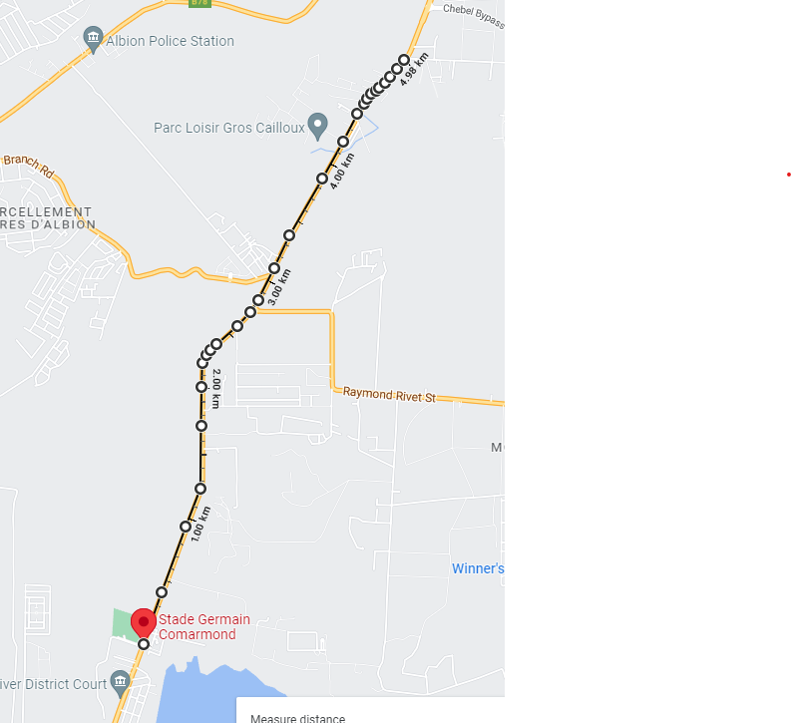

ROAD RACE – BAMBOUS
18 December 2022
COURSE PLAN
START & ARRIVAL

Village Council Gros Cailloux

S/N | Start Time | Run Type | Itinerary | Distance
1 | 07.00 H | ROAD RACE | Start - Stade Bambous to Gros Cailloux village council and Back | 10 kms

