MAURITIUS ATHLETICS ASSOCIATION
ROAD RACE & WALKING EVENTS

Sunday 30 October 2022

Ebène Cyber City

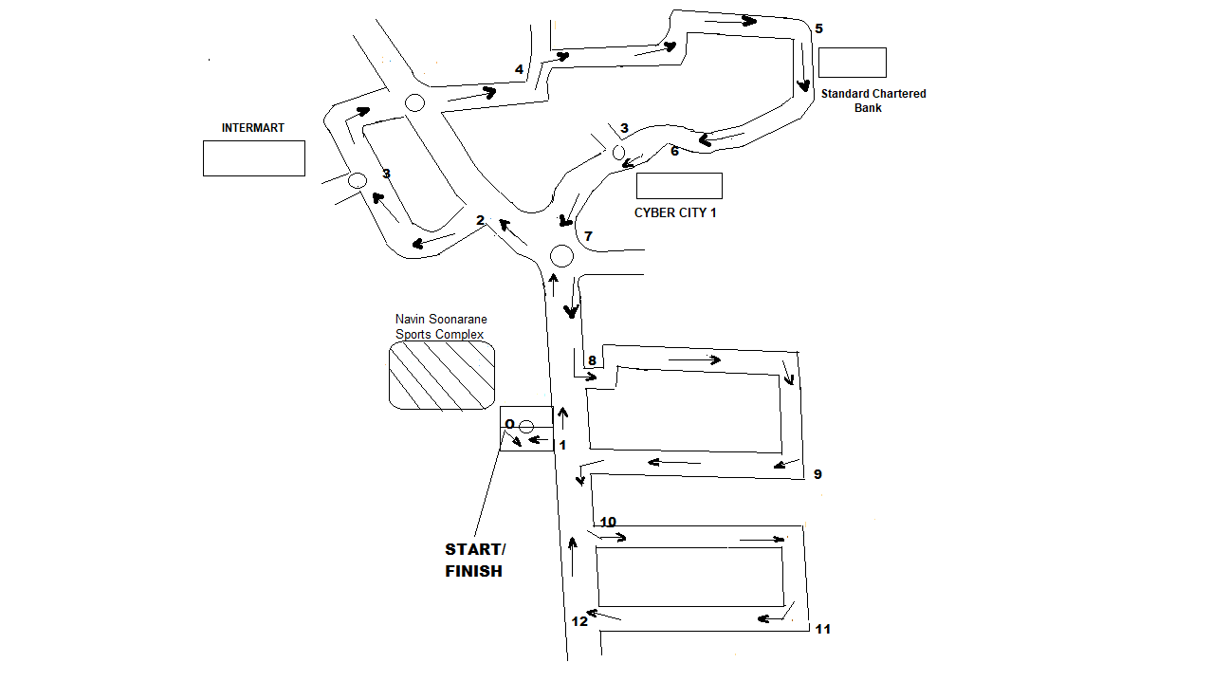
COURSE PLAN

CIRCUIT: 1 – 2 – 3 – 4 – 5 – 6 – 7 – 8 – 9 – 10 – 11 – 12 = 5 KM

TIME | EVENTS | CIRCUIT | DISTANCE
07.00 H | ROAD RACE | Departure O – 1 – 8 – 9 – 10 + 4 Circuits – Arrival O | 21.1 KM
08.00 H | ROAD RACE & WALKING EVENTS | Departure O – 1 Circuit – Arrival O | 5 KM
09.30 H | FUN RUN (Open) | Departure O – 1 – 8 – 9 – 10 – 11 – 12 – 1 - O | 2.5 KM

