sw
Page1
MAURITIUS ATHLETICS ASSOCIATION

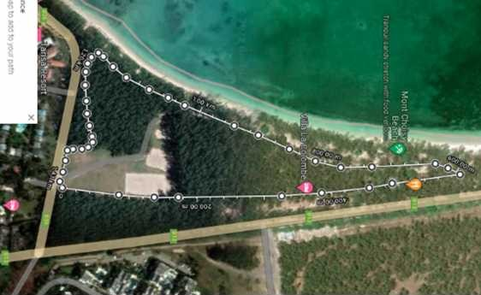
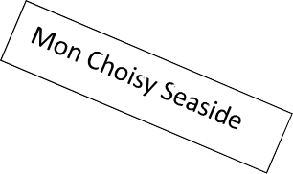
Football ground
E
D
A
To Pointe aux Cannonier
Parking
Public toilet
B
G
C
O
X1
E
VITAL CROSS COUNTRY LEAGUE 2022
3rd Leg – Public Beach, Mon Choisy
Saturday 20th August 2022

Circuit 1 | A – B – C – D – E – F - G – A | 1.4 km
Circuit 2 | A – B – E – F - G – A | 1 km
Circuit 3 | A – O – X1 – F - G – A | 0.8 Km

1 | 09:30 | U 10 - Boys / Girls | Dep A + 1*Circuit 3 – A - O | 0.8 Km
2 | 09:45 | U12 – Boys / Girls | Dep G + 1* Circuit ( 2 ) + A - O | 1.2 Kms
3 | 10:00 | U14 - Girls | Dep A + 2 * Circuit ( 2 ) + A - O | 2 Kms
4 | 10:15 | U 14 Boys / U 16 Girls | Dep A + 2 * Circuit ( 1 ) + A - O | 2.8 Kms
5 | 10:35 | SENIOR Men | Dep F – G – A + 4 * Circuit ( 1 ) + A - O | 6 Kms
6 | 11:05 | U20 Men | Dep G – A + 4 *Circuits (1) | 5.8 Kms
7 | 11.35 | U16 Boys  U18 / Masters Women | Dep A + 3 * Circuit ( 1 ) + A - O | 4.2 Kms
8 | 11:40 | MIXED RELAY – U12 |  | 4 X 300 M
9 | 11:50 | MIXED RELAY – U16 |  | 4 X 500 M
10 | 11:55 | U18 / Master Men  U20 / Senior Women | Dep A + 1* Circuit (3) + 3* Circuits (1) + A - O | 5Kms
11 | 12:00 | KIDS ATHLETICS CHALLENGE

