Page 1

MAURITIUS ATHLETICS ASSOCIATION
VITAL CROSS COUNTRY LEAGUE 2022
4th Leg – Gros Cailloux , BAMBOUS
Saturday 27th August 2022
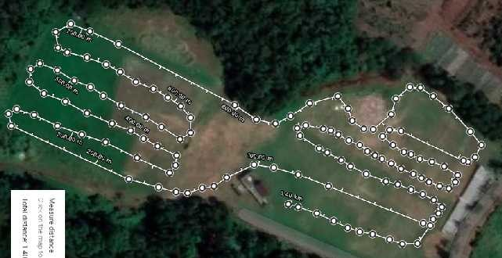
F
G
H
E
D
I
C
B
X
A
CLUB

CIRCUIT A-B-C-D-E-F-G-H- I – A 1.4 Kms

1 | 09:00 | U 10 - Boys | Dep E + F-G + H + I A - X | 800 Mts
2 | 09.10 | U 10 - Girls | Dep E + F-G + H + I A - X | 800 Mts
3 | 09:20 | U12 – Boys | Dep C + D +E + F + G + H + I + A - X | 1.2 Km
4 | 09.30 | U12 – Girls | Dep C + D +E + F + G + H + I + A - X | 1.2 Km
5 | 09.45 | U 14 - Boys | Dep C + D + E + F + G +H + I + A 1* CIRCUIT - X | 2.5 Kms
6 | 10.00 | U 14 – Girls | Dep H + I +A + 1 *CIRCUIT - X | 1.8 Kms
7 | 10.15 | U 16 - Girls | Dep C + D + E + F + G +H + I + A 1* CIRCUIT - X | 2.5 Kms
8 | 10:30 | U 16 - Boys | Dep F + G + H + I + A +2 *CIRCUIT - X | 3.5 Kms
9 | 10:40 | SENIOR - Men | Dep E + F-G + H + I + A + 4 *CIRCUIT - X | 6 Kms
10 | 11.10 | U18 Girls | Dep F + G + H + I + A +2 *CIRCUIT - X | 3.5 Kms
11 | 11.10 | Masters - Women | Dep F + G + H + I + A +2 *CIRCUIT - X | 3.5 Kms
12 | 11.30 | U18 Men | Dep G + H + I + A +3* CIRCUIT - X | 4 .8 Kms
13 | 11.30 | U20 - Women | Dep G + H + I + A +3* CIRCUIT - X | 4 .8 Kms
14 | 11.30 | Senior - Women | Dep G + H + I + A +3* CIRCUIT - X | 4 .8 Kms
15 | 11:50 | U20 Men | Dep G + H + I+ A + 4 *CIRCUIT - X | 5.5 Kms
16 | 11.50 | Master Men | Dep G + H + I+ A + 4 *CIRCUIT - X | 5.5 Kms
17 | 12.15 | MIXED RELAY – U14 |  | 4 X 400 M
18 | 12.15 | MIXED RELAY – U18 |  | 4 X 500 M

