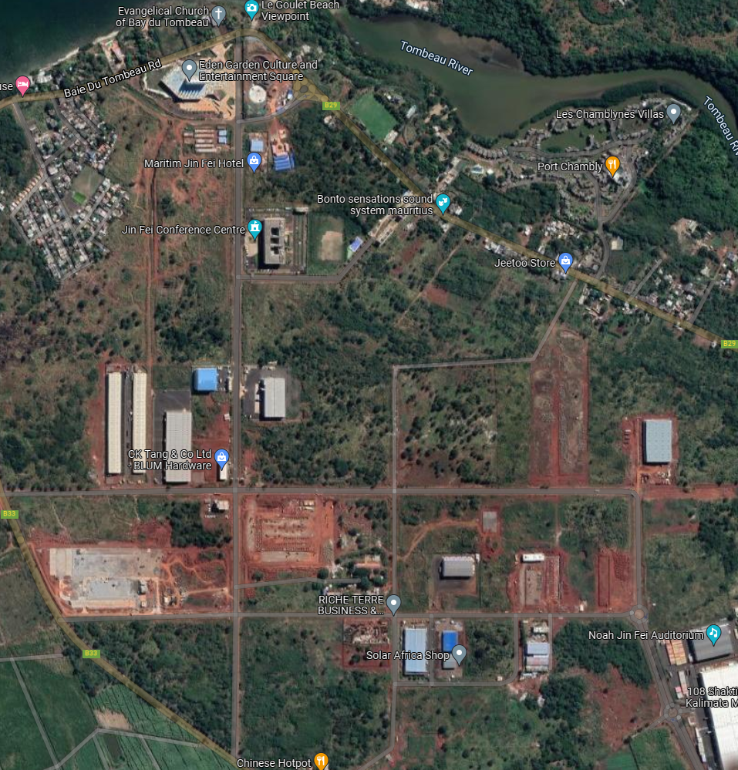
O
ROAD RACE – JIN FEI
07 November 2021
COURSE PLAN
HG
E
F
D
B
G
X
C
A
Loop: 21 KM 100 - A + B + C + D + E + F + O + G + H + A= 5 KM 200
Loop : 10 KM – A + B + C + D + E + F + O + H + A = 5 KM
S/N | Start Time | Run Type | Itinerary | Distance
1 | 07 H 00 | SEMI MARATHON | Start X+ 4 Loops + X | 21.1 kms
2 | 08 H 30 | ROAD RACE | Start X+ 2 Loops + X | 10 kms
3 | 09 H 15 | FUN RUN (Open) | Start X + A + B + A + X | 2 kms

