VITAL CROSS COUNTRY LEAGUE AND NATIONAL CHAMPIONSHIPS

FINAL – SATURDAY 22 AUGUST 2020

Sodnac Wellness Park, Candos
MEMBER FEDERATION

COURSE PLAN
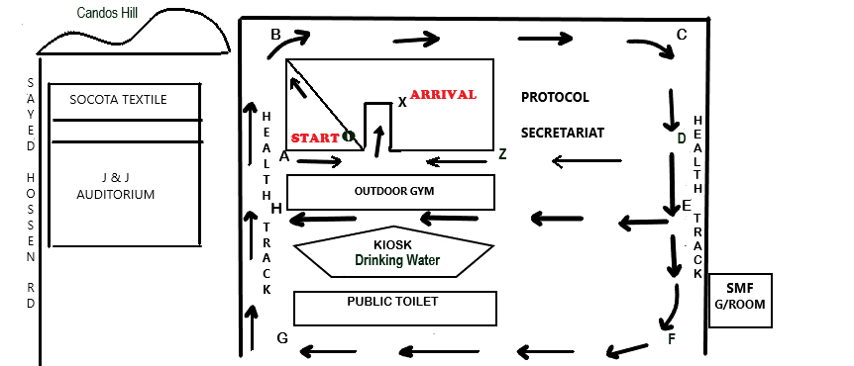

CIRCUIT 1: A – B – C – D – E – H – A - O – X = 1.2 KM
CIRCUIT 2: A – B – C – D – E – F – G – H – A – O - X = 1.8 KM
NO. | CAT | TIME | CIRCUITS | DISTANCE
1 | U12 (G) | 09.00H | DEP O + 1 Circuit (1) – A – O – X | 1.3 KM
2 | U12 (B) & U14 (G) | 09.20H | DEP O + 2 Circuits (1) – A – O – X | 2.5 KM
3 | U14 (B) & U16 (G) | 09.30H | DEP O + 1 Circuit (1) + 1 Circuit (2) - A – O – X | 3.0 KM
4 | U16 (B) & U18 (W) | 09.45H | DEP O + 3 Circuits (1) – A – O – X | 3.7 KM
5 | SEN (M) | 10.05 H | DEP O + 1 Circuit (1) + 3 Circuits (2) – A – O – X | 6.6 KM
6 | U18 (M) & MAS (W) | 10.35 H | DEP O + 4 Circuits (1) – A – O – X | 5 KM
7 | U20 (W) & SEN (W) | 10.55 H | DEP O + 4 Circuits (1) – A – O – X | 5 KM
8 | U20 (M) & MAS (M) | 11.10H | DEP O + 4 Circuits (1) – A – O – X | 5 KM
9 | OPEN RTC MIXED RELAY  (3 Girls + 3 Boys) | 11.30H | O – B – C – D – Z – O - X | 6 X 400M
10 | FUN RUN | 11.40H | 1 Circuit (2) | 1.8 KM

