INTER PRIMARY KIDS ATHLETICS COMPETITION 2018

- AIM

To implement the Kids’ Athletics Programme which forms part of the curriculum of Physical Education in primary schools

TARGET GROUP

5 boys and 5 girls of Grade 5 (10 years in 2018)

RESOURCE PERSONS

H & P E Instructors (Govt & RCEA) and Coaches (MAA)

RESOURCE MATERIALS

IAAF Kids’ Athletics Kits

PERIOD

May and June (Time: 10 a.m. to 1 p.m.)

ORGANISATION OF COMPETITION

The 4 Educational Zones in Mauritius will be divided into 3 Regions namely;

Zone 1 : Port Louis, Pamplemousses and Rivière du Rempart

Zone 2 : Flacq, Moka and Beau Bassin Rose Hill

Zone 3 : Curepipe, Grand Port and Savanne

Zone 4 : Quatre Bornes, Vacoas Phoenix and Black River

And Rodrigues will represent the 13th Region of Zone 5

COMPETITION PHASES

1st Phase – Cluster Level region wise

2nd Phase – Inter Cluster Level region wise

Final Phase – Inter region at national level on 29 June 2018

EVENTS

Sprint Shuttle Relay

Brief description: It is a shuttle relay of two opposite flat sprint distances (2x30m). The relay starts with a team member who has to run forward to hand over the relay ring to another team member on the opposite side who on his turn has to run in opposite direction to hand over the ring. After handing over the ring a runner lines back in the opposite line. The event is completed once each team member has run to and fro the distances. The time taken by the team to complete the relay will be the team’s performance.
The ranking is evaluated according to the best time of each team out of 2 trials.

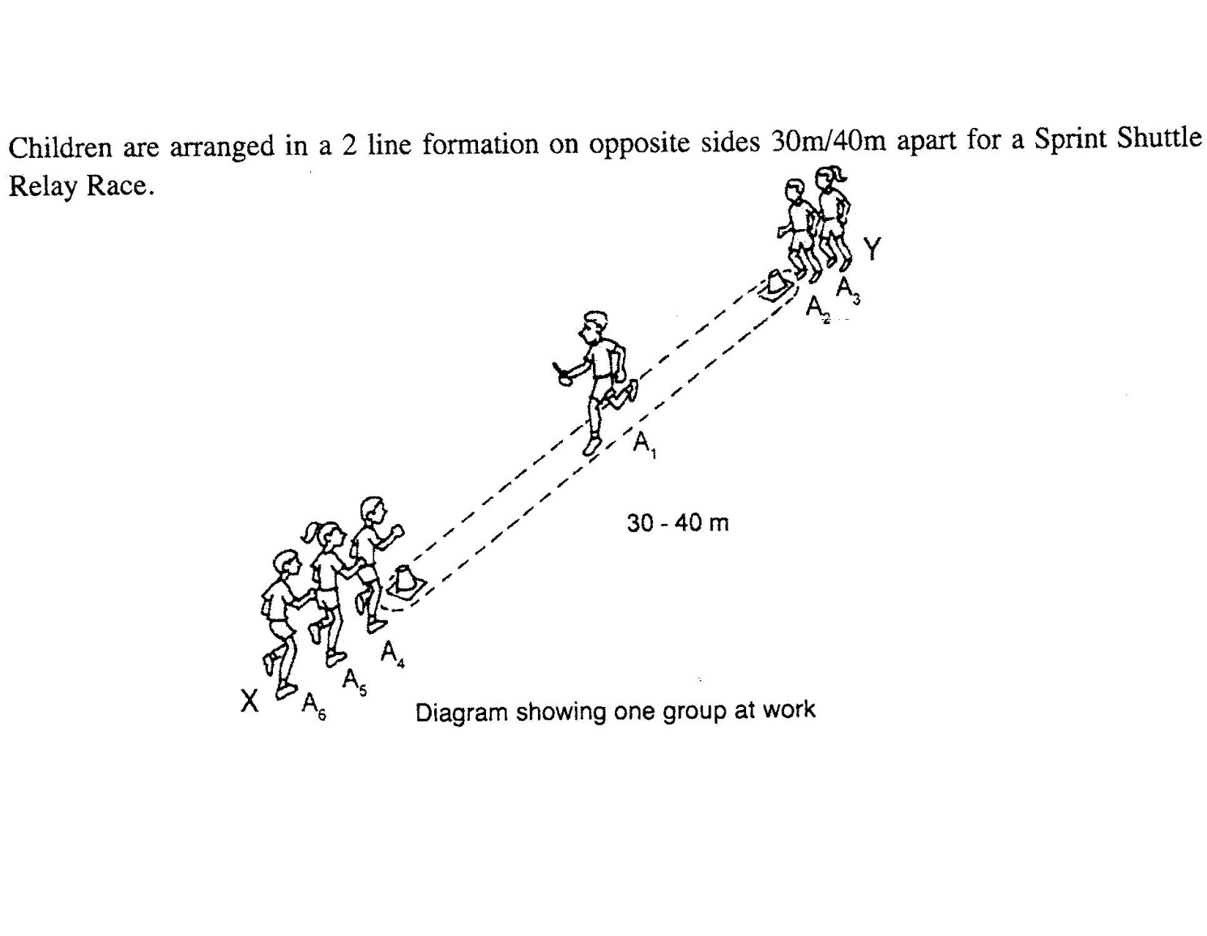

Forward Squat Jump

Brief description: Two feet forward jump from a squat position. The first participant of the team stands with the tips of the toes at the starting line. He/she then squats down and jumps forward as far as possible, landing on both feet. The landing point nearest to the heels of the participant is marked. The second jumper continues with a similar jump from the landing mark of the first jumper and so on for the other jumpers. The event is completed when the last jumper’s landing point is marked and this will be the team’s performance. The distance is recorded.
The ranking is evaluated according to the best distance of each team out of 2 trials.

Knee Throwing

Brief description: The first participant kneels on a mat, leans back and throws the medicine ball (1kg)/Handball using a two- handed over-head forward throw for maximum distance while kneeling. After having thrown the participant may fall forward on the mat. The distance thrown is recorded. Then the next participants throw accordingly

Each participant gets two trials. The better of the two trials of each team member is the one that is included in the team total.
The ranking is evaluated according to the best distance of each team out of 2 trials.

8 minutes Endurance Race

Brief description: Each team has to run around a course of 150m (see figure below) from a given starting point. Team members have to run and stay together around the course during 8 minutes and cover at least 800m. The start command is set for all teams at the same time by blowing a whistle. Each member of the team starts with one point and once a team member walks/runs on the spot the team member loses his/her point. After 7 minutes, the last minute is announced by another blow of a whistle or by starting pistol. After 8 minutes the completion of the run is indicated by a final signal.

The team’s performance is the number of points kept by each team member
The ranking is evaluated according to the number of points scored by each team.

- SCORING
The ranking is based on the results: the winning team being the one with the best total score. The other teams are ranked according to their results order. The points in each event are granted according to the regular procedure (6 teams: 1st score=6 points, 2nd score=5 points, etc.).

- DURATION
1 hour

- STRUCTURE OF ORGANISATION OF COMPETITON – ROTATION FORMULA
- TEAMS 1 and 2 start EVENT 1 and TEAMS 3 and 4 start EVENT2 and TEAMS 5 and 6 start EVENT 3
- After 10 minutes, TEAMS 1 & 2 move to EVENT 2, TEAM 3 and TEAM 4 move to EVENT 3 and TEAMS 5 and 6 move to EVENT 1 and so on.

- PROGRAMME

TEAM | EVENT – 10’ | EVENT – 20’ | EVENT – 30’ | END - 8’
RED | Sprint Hurdles Shuttle Relay | Knee Throwing | Forward Squat Jump | Endurance  8 minutes
BLUE | Sprint Hurdles Shuttle Relay | Knee Throwing | Forward Squat Jump | Endurance  8 minutes
GREEN | Forward Squat Jump | Sprint Hurdles Shuttle Relay | Knee Throwing | Endurance  8 minutes
YELLOW | Forward  Squat Jump | Sprint Hurdles Shuttle Relay | Knee Throwing | Endurance  8 minutes
ORANGE | Knee Throwing | Forward Squat Jump | Sprint Hurdles Shuttle Relay | Endurance  8 minutes
WHITE | Knee Throwing | Forward Squat Jump | Sprint Hurdles Shuttle Relay | Endurance  8 minutes

- FINAL RESULTS
The winner of the competition is the team scoring the highest number of points after addition of points scored in the 4 events

TRANSPORT
PHASE | Financial Assistance (R)
PHASE | 2018
CLUSTER | 300
INTER CLUSTER | 400
FINAL | 500

PARTICIPATION CERTIFICATE AND MEDALS

A Participation Certificate will be awarded to all participants

Medals will be awarded to all team members (13 regions) at National Level for final

- INCENTIVES
Singlets and shorts to all team members for the Final Phase

- COORDINATORS
Giovanni Devalet – Zones 1 & 2 : Mobile Phone – 57 78 65 68
Frankie Lebon – Zones 3 & 4 : Mobile Phone 59 16 13 93

