MAURITIUS ATHLETICS ASSOCIATION

ROAD RACES

Sunday 13 September 2020

Ebène Cyber City

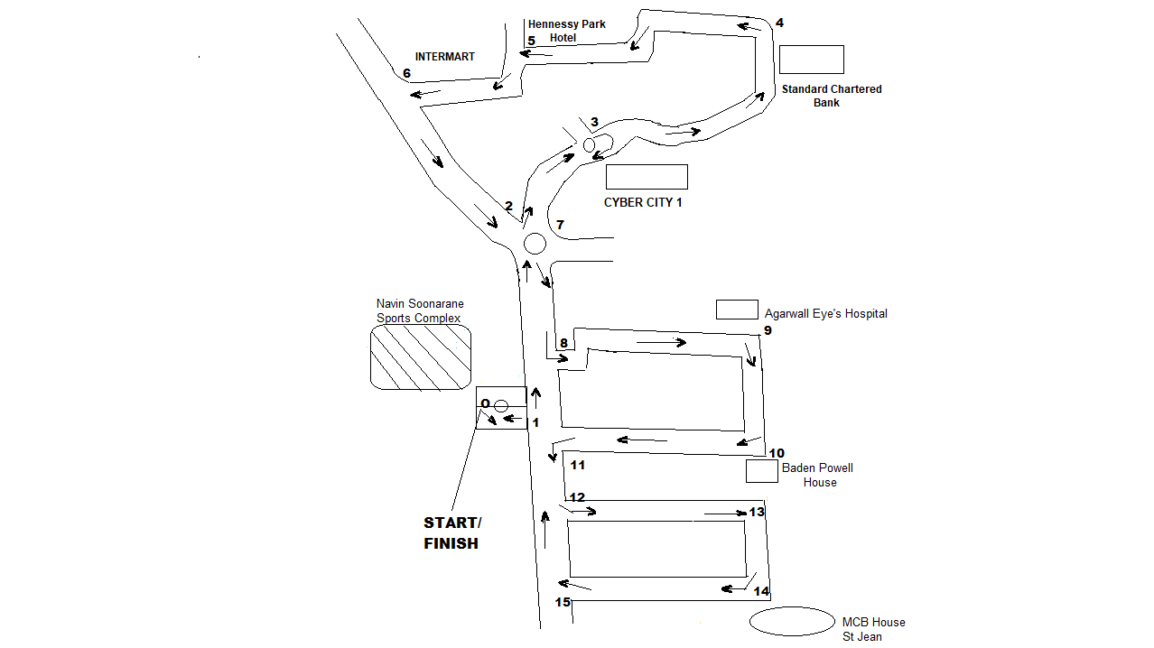
COURSE PLAN

TIME | COURSES | DISTANCES
08.00 H | DEP – 0 – 1 – 2 Circuits – (2 – 3 – 4 – 5 – 6 – 2) + 3 – 7 – 8 – 9 – 10 – 11 – 12 – 13 – 14 – 15 - 1 – 0 | 10 KM
09.00 H | DEP – 0 – 1 – 2 – 3 – 4 – 5 – 6 – 2 - 3 – 7 – 8 – 9 – 10 – 11 – 12 – 13 – 14 – 15 - 1 – 0 | 5 KM
09.30 H | DEP – 0 – 1 – 8 – 9 – 10 – 11 – 12 – 13 – 14 – 15 - 1 – 0 | 2.5 KM

2.5 km and 5 km Open: MAA License not required
10 km: For MAA License Holders only.

